Most likely no arrays nor events on Fa22 Test 3 (items marked in yellow.) Cut and paste items form previous semesters’ tests on JavaScript (JS).

*Javascript*

J1) 2p JavaScript executes script via a(n)

A) compiler

B) interpreter

J2) All of the following could be used as a variable name (identifier) EXCEPT for:

A) 8Previous_bal

B) p_bal

C) previousBalance

D) preBal

J4) If

x = 5;

y = 5;

z = 8;

evaluate the expression (x = = y) || (z < y) (Note: Do == and < , before ||)

The answer is true or false? _______

J5) Evaluate: 3 + 5/2 * 8 = _______

J6) 4p Evaluate:

a) Math.sqrt(16); _______

b) Math.floor(18.7); _______

c) Math.round(58.3); _______

J9) 2p What is the value of y = num1.toFixed(3) if num1 = 4.7253;

J10) In JavaScript, 8/3 evaluates to what answer? (circle one)

A) 0

B) 0.375

C) 2

D) 2.6666

J11) With regards to the code of lines 1 and 2 below:

i = 7; // line 1

document.write(i++); // line 2

Which statement is correct? (circle A or B)

A) Line 2 executes in 2 ways. First it outputs 7 to the page. Afterward i is incremented and i = 8;

B) Line 2 executes in 2 ways. First i is incremented to i = 8;. Afterward it outputs 8 to the page.

J12) 2p The three data types in JavaScript are:

1. booleans (true/false)

2. ______________

3. ______________

J13) Trace the following code. What is the output displayed in the web page?

document.write(“The man said, ‘Goodnight, darling’ ”);

J14) 4p Trace the following code. What is the output displayed in the web page?

// recall x%5 means to find the remainder of x divided by 5.

x = 10;  
if (x%5 = = 0) document.write(“AAA”);

document.write(“<br />”);

document.write( x*7);

document.write(“<br />”);

if (x != 10) document.write(“Hello”);

J15) 3p Trace the following code. What is the output displayed in the web page? Assume 5 and 8 are inputted for num1 and num2, respectively.

num1 = prompt(“Enter the first number: ”);  
 num2 = prompt(“Enter the second number: ”);

result = num1*num2;

document.write(result);

J16) 3p Trace the following code. What is the output displayed in the web page? Use the “trace table” below if helpful.

for (i=1; i <= 3; i++) {  
 document.write(“loop # ” + i)

document.write(“ ----”);

document.write (i*i);

document.write(“<br />”);

}

Use this “Trace table” if helpful:

|  |  |  |  |
| --- | --- | --- | --- |
| i | i < = 3 (test condition) | output: | i++ |
|  |  |  |  |

For the following, assume the code you are tracing and writing is between the <script> tags of the HTML page (or in a separate JS file). That is, it not necessary to show <script> tags in your answers.

The following contain statements that are arithmetic, assignment, input (such as prompt), output, (such as document.write) and for-loop’s

1.

a) Describe the exact output of the following JavaScript code. (Assume the user enters 5 and 7.

[Hint: the parseInt function is applied to the input values for x and y in the code below to prevent a side effect like this: 3 + 4 = 34. The parseInt will be sure to give us correctly: 3 + 4 = 7, instaed. The paresInt function will prevent the concatenation of “3 + 4” from giving us “34”. That is, 3 and 4 are recognized as integers with parseInt instead of text strings!]

**var x = prompt(*"Enter number 1 of 2: "*);  
var y = prompt(*"Enter number 1 of 2: "*);   
document.write(*"x = "* + x + *" y = "* + y);  
document.write(*"<br />"*);  
var z = parseInt(x) + parseInt(y);   
document.write(*"their sum is "* + z);**

b) Describe the exact output of the following JavaScript code. Show a trace in a table or other work if helpful.

[5p]

**for (i=1; i <=3; i++) {  
 document.write(i +*" I will behave in class<br /> "*);  
}  
document.write(*"hello"*);**

c) Write a short program:

(1) Write a program that prompts the user for a number, takes the square root of it and displays it.

Sample output if the user enters 2:

**1.4142135623730951**

2. Functions

a) Change the following program into a function. Name the function **Interest(p, r, t)**.

[7p]

**i = p*r*t;  
document.write(i) ;  
document.write(*"<br />"*);**

b) Give the statement to call the function above with arguments 1000 for **p**, .07 for **r**, and 1 for **t:**

[8p]

________________________

3. Arrays

a) [5p] Declare an array named **animals** and assign it the strings: dog, cat, bird.

b) [5p] For the array **animals** in part a), what is the value of **animals.length**? ____

d) [3p] Suppose an array called **animals** is already declared and contains: [**dog, cat, bird**]. What is the resulting array after executing the statement: **animals.sort(); ?**

e) [3p] Suppose the array **fruits** is already declared and contains: [**mango, apple, pear, orange**]. What is the resulting array after executing: **fruits.pop(); ?**

4. Events. [6pts] The code of the pictured webpage (**below**) has an event handler in it. Refer to the code and describe what the user does and what happens. Be specific.

what does the user do? _________________________________________________

what happens as a result? _________________________________________________

______________________________________________________________________

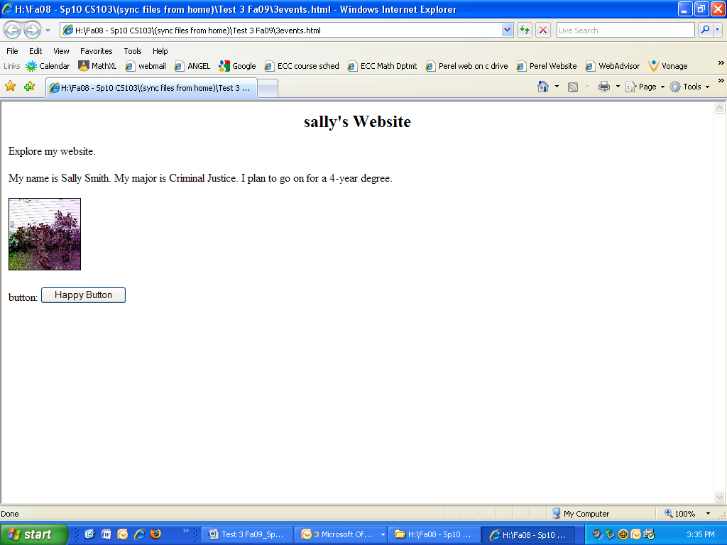<head>

<script>

function fcn3() {

x = prompt("enter your favorite color: ");

alert (x + " is a nice color!");

}

</script>

</head>

<body>

<h2 align="center">sally's Website</h2>

<p> Explore my website.</p>

<p >My name is Sally Smith. My major is Criminal Justice. I plan to go on for a 4-year degree.</p>

<img src="rose.jpg" onmouseover="fcn3()" width="100" height="100" border="1" />

<p></p>

<form name="happyform">

button: <input type="button" name="happy" value="Happy Button" />

</form>

</body>